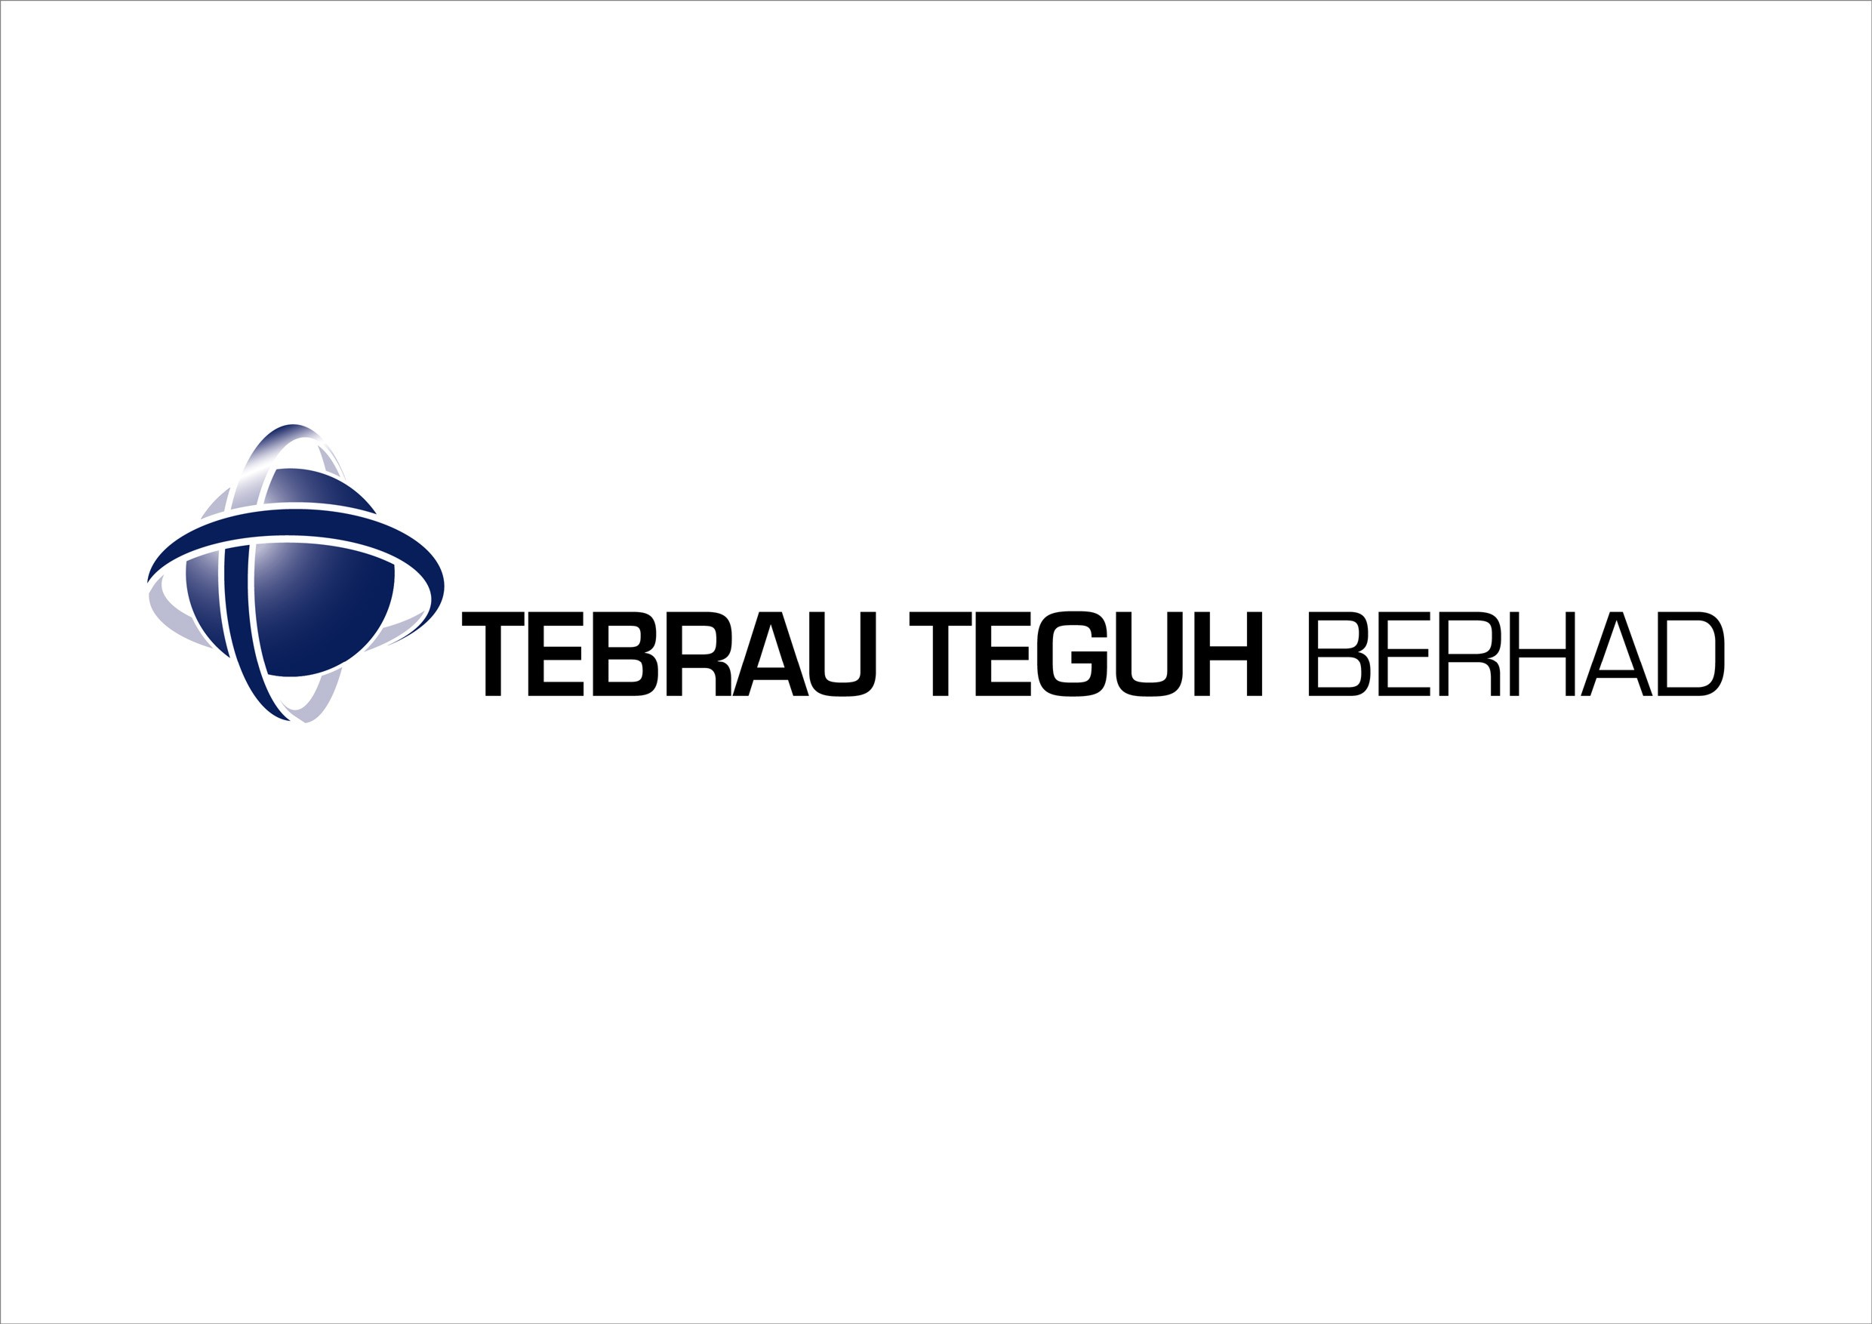

INTERIM FINANCIAL STATEMENTS
FOR THE FINANCIAL PERIOD ENDED 30 SEPTEMBER 2005

CONDENSED CONSOLIDATED INCOME STATEMENTS

 | INDIVIDUAL QUARTER |  | CUMULATIVE QUARTER
 | Current quarter  30.09.05 | Previous year corresponding quarter  30.09.04 | 9 months ended  30.09.05 | 9 months ended  30.09.04
 | RM’000 | RM’000 | RM’000 | RM’000
Revenue | 9,485 | 6,614 | 25,905 | 32,086
Other operating income | 342 | 753 | 681 | 2,914
Operating expenses | (11,160) | (20,770) | (28,032) | (57,855)
Profit/(Loss) from operations | (1,333) | (13,403) | (1,446) | (22,855)
Finance costs | (72) | (24) | (89) | (319)
Share of results of associated companies | - | - | - | -
Profit/(Loss) before taxation | (1,405) | (13,428) | (1,535) | (23,173)
Taxation | 459 | 462 | (65) | 339
Profit/(Loss) after taxation | (946) | (12,966) | (1,600) | (22,835)
Minority interest | - | - | - | -
Net profit/(loss) for the period | (946) | (12,966) | (1,600) | (22,835)

EARNINGS/ (LOSS) PER SHARE
Basic (sen) | (0.14) | (1.94) | (0.24) | (3.41)
Diluted (sen) | N/A | N/A | N/A | N/A

The Condensed Consolidated Income Statement should be read in conjunction with the annual audited financial statements for the year ended 31 December 2004.

CONDENSED CONSOLIDATED BALANCE SHEETS

 | Unaudited as at  30.09.05  RM’000 |  | Audited as at  31.12.04  RM’000
NON-CURRENT ASSETS
Property, plant and machinery | 4,232 |  | 4,803
Investments in associated companies | 2,322 |  | 2,322
Investment properties | 1,602 |  | 1,602
Other investments | 90 |  | 90
Land held for future development | 189,035 |  | 189,035
Deferred tax assets | 58 |  | 58
 | 197,339 |  | 197,910
CURRENT ASSETS
Development properties | 411,699 |  | 409,737
Inventories | 656 |  | 1,094
Trade receivables | 35,779 |  | 42,205
Other receivables | 24,266 |  | 26,495
Cash and bank balances | 18,751 |  | 9,434
 | 491,151 |  | 488,965
CURRENT LIABILITIES
Trade payables | 39,559 |  | 41,053
Other payables | 17,165 |  | 11,605
Borrowings | 6,157 |  | 6,199
Tax payable | (151) |  | 118
 | 62,730 |  | 58,975
NET CURRENT ASSETS | 428,421 |  | 429,990
 | 625,760 |  | 627,900
FINANCED BY:
Share capital | 334,864 |  | 334,864
Reserves | 136,299 |  | 137,899
Shareholders’ equity | 471,163 |  | 472,763
NON-CURRENT LIABILITIES
Borrowings | 14,689 |  | 14,963
Deferred taxation | 139,908 |  | 140,174
 | 625,760 |  | 627,900
Net tangible assets per share (RM) | 0.70 |  | 0.71

The Condensed Consolidated Balance Sheets should be read in conjunction with the annual audited financial statements for the year ended 31 December 2004.
CONDENSED CONSOLIDATED STATEMENT OF CHANGES IN EQUITY

 | Share capital  RM’000 | Share premium  RM’000 | Exchange fluctuation reserve  RM’000 | Accumulated losses  RM’000 | Total  RM’000
At 1 January 2004 | 334,864 | 528,127 |  | (363,429) | 499,562
Issue of share capital | - | - | - | - | -
Net Loss for the year | - | - | - | (22,835)) | (9,868)
Accumulated losses written off against share premium account | - | (302,306) | - | 302,306 | -
At 30 Sept 2004 | 334,864 | 225,821 | - | (83,957) | 476,727
At 1 January 2005 | 334,864 | 225,821 | - | (87,922) | 472,763
Net loss for the period | - | - | - | (1,600) | (1,600)
At 30 Sept 2005 | 334,864 | 225,821 | - | (89,522) | 471,163

The Condensed Consolidated Statements of Changes in Equity should be read in conjunction with the annual audited financial statements for the year ended 31 December 2004.
CONDENSED CONSOLIDATED CASH FLOW STATEMENTS

 | 9 months ended 30.09.05  RM’000 |  | 9 months ended  30.09.04  RM’000
Net cash generated from/(used in) operating activities | 9,856 |  | (18,181)
Net cash generated from/(used in) investing activities | 190 |  | (687)
Net cash generated from/(used in) financing activities | (729) |  | 15,231
Net increase/(decrease) in cash and cash equivalents | 9,317 |  | (3,637)
Cash and cash equivalents at beginning of year | 9,434 |  | 10,416
Cash and cash equivalents at the end of quarter | 18,751 |  | 6,779
Cash and cash equivalents comprise:
Cash and bank balances | 7,546 |  | 6,624
Deposit with licensed banks | 11,205 |  | 155
 | 18,751 |  | 6,779

The Condensed Consolidated Cash Flow Statements should be read in conjunction with the annual audited financial statements for the year ended 31 December 2004.

INTRODUCTION

The interim financial statements of Tebrau Teguh Berhad (“the Company” or “TTB”) and of the Group are unaudited and have been prepared under the historical cost convention and in accordance with FRS 134; Interim Financial Reporting and Paragraph 9.22 of the Listing Requirements of Bursa Malaysia Securities Berhad.

The interim financial statements should be read in conjunction with the Group’s audited financial statements for the year ended 31 December 2004. The accounting policies, method of computation and basis of consolidation adopted for the interim financial statements are applied consistent with the property and development industry, the Companies Act 1965 and the Approved Accounting Standards.

AUDITORS’ REPORT OF THE PRECEDING FINANCIAL YEAR ENDED 31 DECEMBER 2004

The Auditors’ Report of the financial statements of the Company and of the Group for the year ended 31 December 2004 was not subject to any qualification.

SEASONAL OR CYCLICAL FACTORS

The Group’s business operations are not seasonal but cyclical in nature, which is dependent on the economic conditions in Malaysia.

UNUSUAL ITEMS

There were no unusual items affecting assets, liabilities, equity, net income, or cash flows during the financial period under review because of their nature, size, or incidence.

CHANGES IN ESTIMATES

There were no changes in estimates of amounts reported in previous quarters of the current financial year or changes in estimates of amounts reported in prior financial years that have had a material effect in the current quarter.

DEBTS AND EQUITY SECURITIES

There were no issuances and repayment of debts and equity securities, share buy-backs, share cancellations, shares held as treasury shares and resale of treasury shares during the financial period ended 30 September 2005.

DIVIDENDS

No dividends are recommended, have been declared, or have been paid during the financial quarter ended 30 September 2005.

VALUATION OR PROPERTY, PLANT AND EQUIPMENT

The valuations of property, plant and equipment have been brought forward without amendment from the audited financial statements for the year ended 31 December 2004.

MATERIAL EVENTS SUBSEQUENT TO THE END OF THE INTERIM PERIOD

There were no material events subsequent to the end of the current quarter that have not been reflected in the quarterly financial statements.

GROUP COMPOSITION

There were no material changes in the composition of the Group during the financial quarter under review.

CHANGES IN CONTINGENT LIABILITIES OR CONTINGENT ASSETS

Contingent liabilities of the Group comprise the following:

 | 30.09.05 | 31.12.04
 | RM’000 | RM’000
Corporate guarantees given by the Company to financial institutions for facilities granted to subsidiaries | 52,200 | -
Corporate guarantees given by the Company to developers for the completion of construction works undertaken by a subsidiary. | 14,997 | 6,567
Performance bond issued by subsidiaries involved in construction activities | 16,951 | 5,524

SEGMENTAL REPORTING

Analysis by Activities
 | Turnover  Year To Date |  | Profit/Loss before  Taxation  Year To Date
 | 30.09.05  RM’000 | 30.09.04  RM’000 | 30.09.05  RM’000 | 30.09.04  RM’000
Property development | 15,404 | 18,579 | 2,614 | (3,524)
Construction | 10,041 | 14,562 | (1,167) | (14,142)
Property Management | 632 | - | (28) | -
 | 26,070 | 33,141 | 1,419 | (17,666)
Share of results of associated company | - | - | - | -
Consolidation adjustment | (171) | (1,055) | (1,169) | (2,669)
 | 25,905 | 32,086 | 304 | (20,336)
Unallocated corporate expenses | - | - | (1,750) | (2,519)
Interest expense | - | - | (89) | (319)
 | 25,905 | 32,086 | (1,535) | (23,173)

No segmental reporting on geographical location is prepared as the Group’s activities are carried out in Malaysia.

REVIEW OF PERFORMANCE

(i) Comparison with the preceding quarter

The Group recorded a lower turnover and a loss before tax for the current quarter ended 30 September 2005 compared to the preceding quarter ended 30 June 2005 due to low property sales and reduction in construction activities.

(ii) Comparison with the previous corresponding quarter and financial period

The lower turnover and loss before tax for the current quarter ended 30 September 2005 compared to the previous corresponding quarter ended 30 September 2004 was mainly due to revenue and profit recognition arising from progress of the existing development and the turnover from construction contract under JPN.

The higher loss in the previous corresponding quarter was due to high overhead and additional provision of expenses required to complete construction projects.

PROSPECTS

For property development division, the Group is focusing on selling and completing the existing project. Currently new products are being developed, but due to the soft property market, the Group is carefully planning its next launch. The initial target for new launch will be next year.

The Group construction division has commenced work for the RM83.5 million contracts for construction of 1,500 unit’s low cost housing in Taman Sri Stulang, Johor Bahru for JPN. The contract is expected to be completed in Nov 2006. The Group will remain focus on completing the other existing construction contracts.

The Group does not expect any material improvement to the current year’s results.

The Group continues to seek new opportunities for its core businesses i.e. property development and construction to further expand its future earnings.

PROFIT FORECAST

The Group has not provided any profit forecast in a public document.

TAXATION

Income tax expense | Current year quarter  30.09.2005  RM’000 | 9 months cumulative to date  30.09.2005  RM’000
Malaysian Income Tax
- previous year | - | -
- current year | 284* | (331)
Transfer to/(from) deferred taxation | 175 | 266
 | 459 | (65)

* Being a write back of overprovision of taxation in the 2nd quarter.

UNQUOTED INVESTMENTS AND PROPERTIES

There were no purchases or sales of unquoted investments and properties for the current quarter and financial year to date.

QUOTED INVESTMENTS

There were no purchases or sale of quoted securities for the current quarter and financial year to date.

There were no investments in quoted securities as at the end of the current quarter.

STATUS OF CORPORATE PROPOSALS

The status of corporate exercise announced but not completed is set out below.

The proposed capitalisation and issuance of 4,999,998 new ordinary shares of RM1.00 each in Langkawi Airport Hotel Sdn Bhd (“LAH”), a wholly owned subsidiary of the Company (“Proposed Capitalisation”) has been approved by the shareholders of the Company on 30 December 2003. The completion of the Proposed Capitalisation remains pending the necessary approvals needed to be obtained by Ekran Berhad, the proposed subscriber of the new shares in LAH to be issued.

BORROWING AND DEBT EQUITIES

Details of the Group’s borrowings as at 30 September 2005 are as follows:

 | Current |  | Non current
 | RM’000 |  | RM’000
Bridging loans (secured) | 3,672 |  | 14,303
Short Term Advance (secured) | 1,910 |  | 0
Hire purchase & leasing liabilities | 574 |  | 386
Total | 6,157 |  | 14,689

As at 30 September 2005, RM23.1 million has been drawdown from the bridging facilities of RM35 million under the Principle of Bai’bithaman Ajil with Bank Kerjasama Rakyat Malaysia Bhd. Approximately RM4.7 million has been repaid through the redemption from sale of development properties products. The non-current portion of the bridging loan due to be fully repaid by 2008.

The group has secured a RM 3 million Short Term Advance facilities from BCB Bank Bhd. to part finance the construction contract for Taman Sri Stulang under JPN. As at 30 September 2005, the facilities has been fully drawdown and total repayment of RM 1.09 million have been made.

OFF BALANCE SHEET FINANCIAL INSTRUMENTS

There were no off-balance sheet financial instruments.

MATERIAL LITIGATION

 | Case No./Parties | Remarks and status
1 | Kuala Lumpur High Court No.  D7-22-1299-99  GIB vs Malayan Banking Berhad (“MBB”) | This case is in relation to the claim of RM2,674,828.83 plus costs and interest against MBB.  The Judge has dismissed the suit due to non-compliance with the case management on 20 June 2005.  This legal case is a continuing responsibility of Diamond League Sdn Bhd (“DLSB”) pursuant to the Deed of Sale cum Trust Deed dated 26 April 2002 entered into between DLSB and the Company. The outcome of the legal case will not have any effect on the financial position of the Company.
2 | Johor Bahru High Court No.  24-2894-2003(4)  Tebrau Bay Sdn Bhd (“TBSB”) vs United Victoria Sdn Bhd (“UVSB”) and Kong Sun Enterprise Sdn Bhd (“KSE”) | This legal case is in relation to a claim of RM12.6 million by TBSB, a wholly owned subsidiary of the Company, against the Defendants in respect of the sale of 51% equity interest in Asset Nusantara Development Sdn Bhd to the Defendants.  The case has been fixed for final mention date on 2 December 2005. Notice of Demand has been issued to KSE & UVSB dated 26 October 2005.

EARNINGS AND LOSS PER SHARE

The basic earnings/ (loss) per share for the financial period has been calculated based on the Group’s earnings/ (loss) after taxation and dividend by the 669,727,143 ordinary shares of RM0.50 each in issue during the financial period. There have been no dividends paid in the current period to date and in the prior year.

